Client Side
see code of samples/savedata_grid.html

Server Side
files are in samples/DataLink

Configuring DataSource
Set necessary connection settings in db.php Only purpose of this file is to set DB connection.

Configuring select query
The get.php file describe select query
The line:
$temp=new uDataLink("data.xml");
define configuration xml

Configuring INSERT/UPDATE/DELETE
The update.php file describe INSERT/UPDATE/DELETE query
The line:
$temp=new uDataLink("data.xml");
define configuration xml

Configuration XML
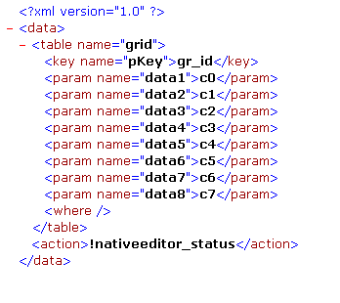
The “table” tag set used table name
The “key“ tag describe primary key of record
The “name” attribute set name of field in DB
The tag value set the name of received parameter
gr_id - id of grid row
cN – data of column with index N
any_other_value – userdata of grid row
The “param” tag describe column in grid
The “name” attribute set name of field in DB
The tag value set the name of received parametr
“where” tag may contain additional SQL rules, which will be added to WHERE clause of SQL query. For example
<where><![CDATA[ pky >100 AND pk < 200 ]]</where>
The “action” tag is used by auto updater script, and is mandatory.

